BUSINESS PROPOSAL
- Project Background
  - What is the work that have been carried out to produce a workable Proof of Concept?
  - How will your proposed project fulfill the existing gaps and addressing national strategic issues?

- Project Overview
  - Project objective(s)
State clearly the project objective(s).
  - Project summary
Please describe briefly the project. Key information should include:
    - Key activities
    - Duration of project
    - Key collaborators
  - Immediate target industry/market
Please describe briefly the target
    - Industry
E.g. telco
E.g. factory
    - Potential/target customer
E.g. celcom

- Project Description
Elaborate on the following:
- Problem Statement
[What problems are you addressing?]
- Novelty/Uniqueness.
[How is it different from existing ones – its uniqueness, inventiveness and innovativeness]
- Proof of Concept (POC)/Prototype

- Methodology
Elaborate on the following:
- Methods / Process / Technology
[Describe the details of the process]
- Process Flow Chart/Diagram
[Explain the diagram clearly together with other relevant input]
- Standard/Regulation/Ethical Compliance (if applicable)
[Explain clearly what are the required Regulations/Certification Scheme/
Standards that you have to follow and how you intend to fulfill them]
- Current Development Status
[Describe what is the current developmental status of the proposed project]

- Technical & Commercial Milestones
Details on technical and commercial milestones, activities and expected outputs to be achieved during the project’s implementation and completion]
No | Milestones | Activities | Deliverable | Duration (months) | Estimated Cost (RM)
1.
2.
3.
4.
5.
6.
TOTAL COST (RM)

- Deliverables and Way Forward
Expected Deliverables
[Please detail out output/outcome of the project - Revenue, IP, Human Resource, Publication, etc.]

Sustainability
[Please explain the plan to ensure project’s sustainability]

Way Forward
[Please explain the plan for next course of action after the project is completed]

- Potential Contributions and Impact
- Describe the contributions of project - problem solving, cost reduction, strategic needs and living standards
- Impact of the project to social, economy and environmental.

- Project Costing

 | Component | Amount requested (RM) | Total cost for each component (RM)
A | Pilot Plant/ Prototype  i……..  ii……..
B | Field Trial/Stress Test/User Acceptance
C | IP Preparation & Registration |  | The amount that you should put here should be the sub-total for each component. The Panel will refer to your excel file of detail breakdown costing for a more detailed funding requirements.
D | Market Testing/ Evaluation
E | Regulatory & Standard Compliance
F | Special Services
G | Administration
H | Raw Materials/Consumables
I | Technology/ IP Acquisition (if Applicable)
TOTAL (RM)

- Project Risk
Please provide an assessment of the project risk and mitigation plan (measures).
Risk | Risk level |  |  | Measures
Risk | High | Medium | Low | Measures
 | X

- Business Model Canvas

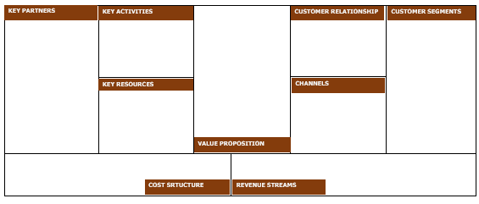

- Marketing Plan
Marketing plan shall present following items:

- Strengths, Weaknesses, Opportunities and Threats (SWOT) analysis. Please includes product competitive analysis.

- Target market profile including demographic, estimated demand and motivation for product procurement.

- Market objectives.

- Marketing Strategy.

- Contact Details
Organization:
Contact Person:
Address:
Tel:
Email:

